Lesson 9.3 Speed and velocity

Recommended teaching time for this lesson: 1 x 60 minute period

• 35 minutes of explicit teaching

• 25 minutes of suggested classroom activities

• 30 minutes homework

Getting started

Key ideas

* Speed is the rate at which a distance is covered; it is a scalar quantity.
* Velocity is the rate of change of displacement of an object; it is a vector quantity.

Curriculum links

Science understanding

* Describe the concepts of displacement, velocity and acceleration.
* Compare instantaneous and average velocity.

Advice for teaching this lesson

Things to know before you start teaching

At this stage of the course, most scenarios when analysing movement will involve motion in one dimension only going in one direction, e.g. just going forwards. As such speed and velocity will be the same because distance and displacement will be the same. However, texts, online resources, or sample exam questions may use this language interchangeably. This can be problematic when teaching to students as teachers will understand what is meant by context, but students may not conceptually understand that they can be the same thing under certain circumstances.

Complex questions in this topic will involve the use of simultaneous equations. Ensure that students are setting out the information given in the question using appropriate symbols to continue building good habits from the previous unit. This will allow them to identify common variables in different systems of motion for cancelling. Generally the linking variable will be time.

Common misconceptions

* Students will often get conceptually stuck on the idea that velocity and speed both have to be numerically present. Activity 1 will force them to deal with this concept.

Differentiation strategies

Students must have the foundational understanding of distance vs displacement before moving on past this point, or a large amount of this unit will have significant problems. Some ways to ensure that students understand this are below.

* Definition approach – have students work on the concepts from a vocabulary point of view with describing scenarios and classifying them as displacement or distance.
* Mathematical approach – focus on a strict numerical calculation style where students know to add lengths travelled for distance or add/subtract based on direction for displacement.
* Graphical approach – focus on having students represent the movement of objects using arrows to visually show the required displacement or distance. The worked examples will help with this.
* Kinematic approach – get students to act out questions and the concepts to physically demonstrate using tools such as rulers/measuring tapes the two concepts.

Starter activity: Conversion

Approximate time: 5 minutes

**Activity placement:** Place directly after Lesson overview

**Activity summary:** Revising how to convert between km/h and m/s.

Notes for the teacher

Speed/velocity values being given in km/h is fairly common when dealing with motion scenarios, and can occur on QCAA exams. However, a conversion tool is expected knowledge. Having an easy reference for students is a useful tool.

Emphasise to students that the magnitude of the number when converting from km/h to m/s will always go down. For example 100 km/h is 27.8 m/s. They’re equivalent speeds, but the number looks smaller.

Instructions for students

Recall or research the conversion between km/h and m/s.

* 1. Construct a summary table or graphic that you can use as a reference for conversions through this unit. You should have two conversions, one for km/h to m/s, and one for m/s to km/h.

Answers

1. Student answers will vary. Two examples are provided.

$${km}/h÷3.6→m/s \\ m/s×3.6→{km}/h$$

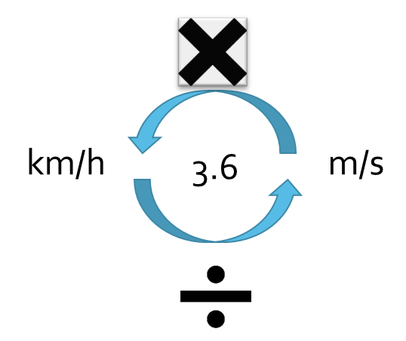

Classroom activity: Does that seem right?

Approximate time: 10 minutes

**Activity placement:** Place directly above “Worked example 9.3A”

**Activity summary:** Practice for students to evaluate claims by referring to physical equations and understanding of concepts as evidence.

Notes for the teacher

Students should reach the conclusion that the claim is true.

Encourage students to use equations to support their statements. They can do this with algebraic representation only, or with numeric substitution.

Instructions for students

Read the following claim.

“You can have a speed that is greater than 0 m/s, and a velocity that is equal to 0 m/s, at the same time.”

1. Evaluate the given claim as true or false. Support your evaluation with evidence from theory.

Helpful hints

* Consider using the equations for speed and velocity. Remember if you don’t feel comfortable with just using algebra you can create some example numbers.

Answers

1. Student answers will vary. The following is a sample answer.  
   Speed is defined as the rate of change of distance. Because distance is scalar when an object is moving this means that distance can only ever increase. Velocity however is the rate of change of displacement. Displacement is a vector measurement and represents the distance between start and finish with no consideration for how you got there. If you were to return to your starting position you would have a velocity of 0 m/s as your displacement would be 0 m, however you would have a non-zero speed as your distance is not zero. Therefore the claim is true, you can have a speed that is greater than 0 m/s, and a velocity of 0 m/s at the same time.

Classroom activity: How fast is that?

Approximate time: 10 minutes

**Activity placement:** Place directly above “Check your learning 9.3”

**Activity summary:** A research activity to have students examine common speeds of a variety of events.

Notes for the teacher

Students often have poor self-check skills for the results of their calculations, and very often this skill is overlooked as part of the problem-solving approach. Encouraging students to have a reference table that they use can help them identify if their answers are reasonable, and hence whether their approach is likely to be correct.

The scale is intended to be quite stretched out. Students do not realise just how slow their everyday world is.

Instructions for students

Step 1: Research the speeds of the following events:

* average human walking speed
* average human running speed
* a car driving through a school zone
* a car driving down a highway
* a domestic (within Australia) passenger plane
* a military jet.

1. Construct a scale showing the speeds of your researched objects in correct scientific units.

Helpful hints

* Don’t stress about perfectly accurate values. Depending on what you use as your research source you will likely get some small variances between your peers.
* Consider using technology to convert the speeds yourself. Do not trust the AI summaries that web searches produce for numerical values because these are not always accurate. However, the conversion tools are accurate if you do the work yourself.

Support activity

Notes for the teacher

This replaces the scale instruction for a simpler presentation of a table.

Instructions for students

Step 1: Research the speeds of the following events:

* average human walking speed
* average human running speed
* a car driving through a school zone
* a car driving down a highway
* a domestic (within Australia) passenger plane
* a military jet.

1. Construct a summary table showing the speeds of your researched objects in correct scientific units.

Challenge activity

Notes for the teacher

This extends the original task to have students compare how these values measure up against physical constants.

Instructions for students

Research the speeds of the following events:

* average human walking speed
* average human running speed
* a car driving through a school zone
* a car driving down a highway
* a domestic (within Australia) passenger plane
* a military jet.

1. Construct a scale showing the speeds of your researched objects in correct scientific units.
2. Compare the speeds of the objects on your list, with that of sound, the orbit of the Earth, and the orbit of the Sun (around the galactic centre)

Answers

1. Student answers may vary slightly depending on reference objects used.

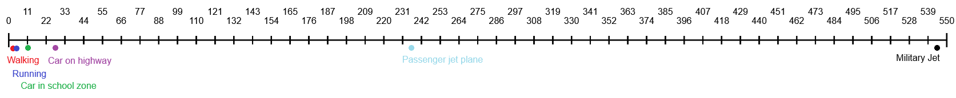

Support activity

1. Student answers may vary slightly depending on reference objects used.

|  |  |
| --- | --- |
| Object | Speed (m/s) |
| Walking | 1.34 |
| Running | 3.05 |
| Driving (School zone) | 11.1 |
| Driving (Highway, Qld) | 27.8 |
| Passenger Jet | 236 |
| Max speed of F-35A | 544 |

Challenge activity

1. Student answers will vary depending on reference values used. 
2. Sound would appear slightly above the passenger jet plane (around 343 m/s depending on air temperature) so students can recognise that military planes often fly faster than you can hear them. The speed of the Earth’s orbit is around 30000 m/s so significantly off this scale, while the Sun’s orbit around the Milky way is about 217000 m/s which would dwarf the scale if the Earth’s motion was placed onto it.